Statement
INSERT INTO Location(LocNo, FacNo, LocName)
VALUES ('L108','F104','Locker Room');

Before (8 rows)
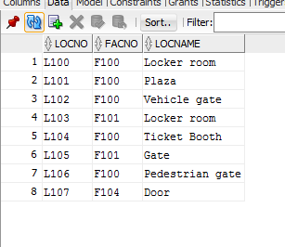

After(9 rows)
